Topic: Measurement | EQ: Estimating vs Measuring- What and When?
Questions  What is estimation?  Examples: | Notes:  When we estimate we are making a smart guess about something. Estimating isn’t always accurate, but gives us a rough idea of a length.  It is important to use appropriate units when estimating. If something like a skyscraper is really tall, what unit would you use to estimate the height? Millimetres would be too small and kilometres would be too big. The best unit for this situation would be metres.  1 adult step is about 1m. We can use this to estimate distances.  Our classroom:  room is 8 steps wide  This means we can estimate the room to be 8m wide.  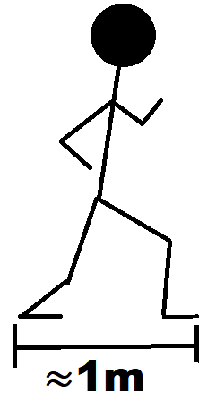  Estimate the length of your bedroom  Number of steps = _______  So your bedroom is estimated to be ______m

WORKSHEET
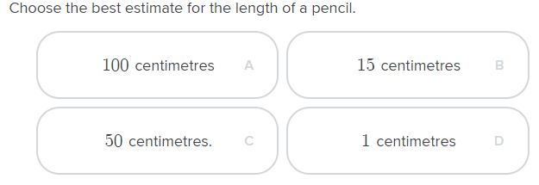
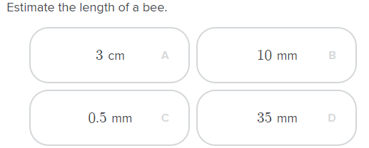
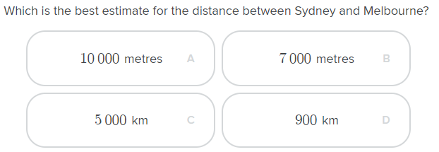
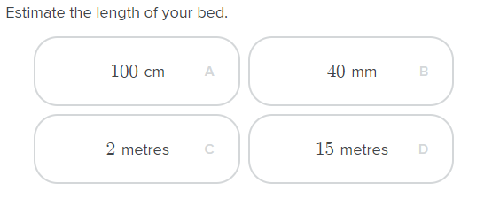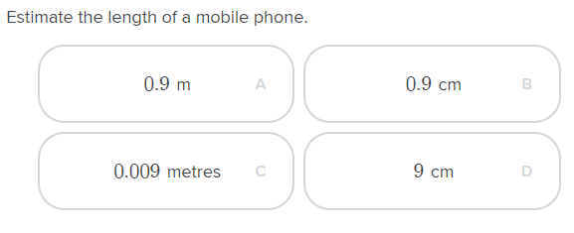

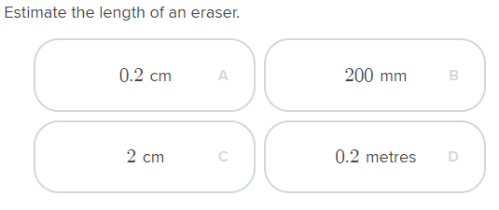
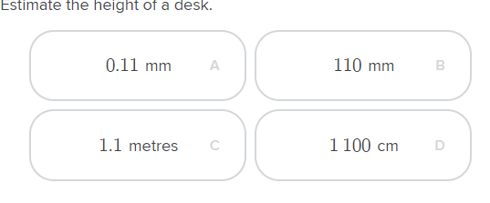
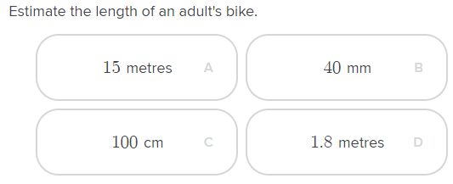

Measuring and Estimating task.
Estimate the area of your back yard
Width:
Length:

Multiply these together to estimate the area of your back yard.

If you have a measuring tape or the house plans, check to see how close your estimations were.

